ASSIGNMENT-4

DISTANCE DETECTION USING ULTRASONIC SENSOR

|  |  |
| --- | --- |
| Date | 22 October 2022 |
| Team ID | PNT2022TMID110 52 |
| Name | Prasanna Venkatesan |
| Student Roll Number | 811519106103 |
| Maximum Marks | 2 Marks |

# Question1:

Write code and connections in work for ultrasonic sensor. Whenever distance is less than 100 cms send "alert" to ibm cloud and display in device recent events.

WOKWI LINK:

https://wokwi.com/projects/305566932847821378

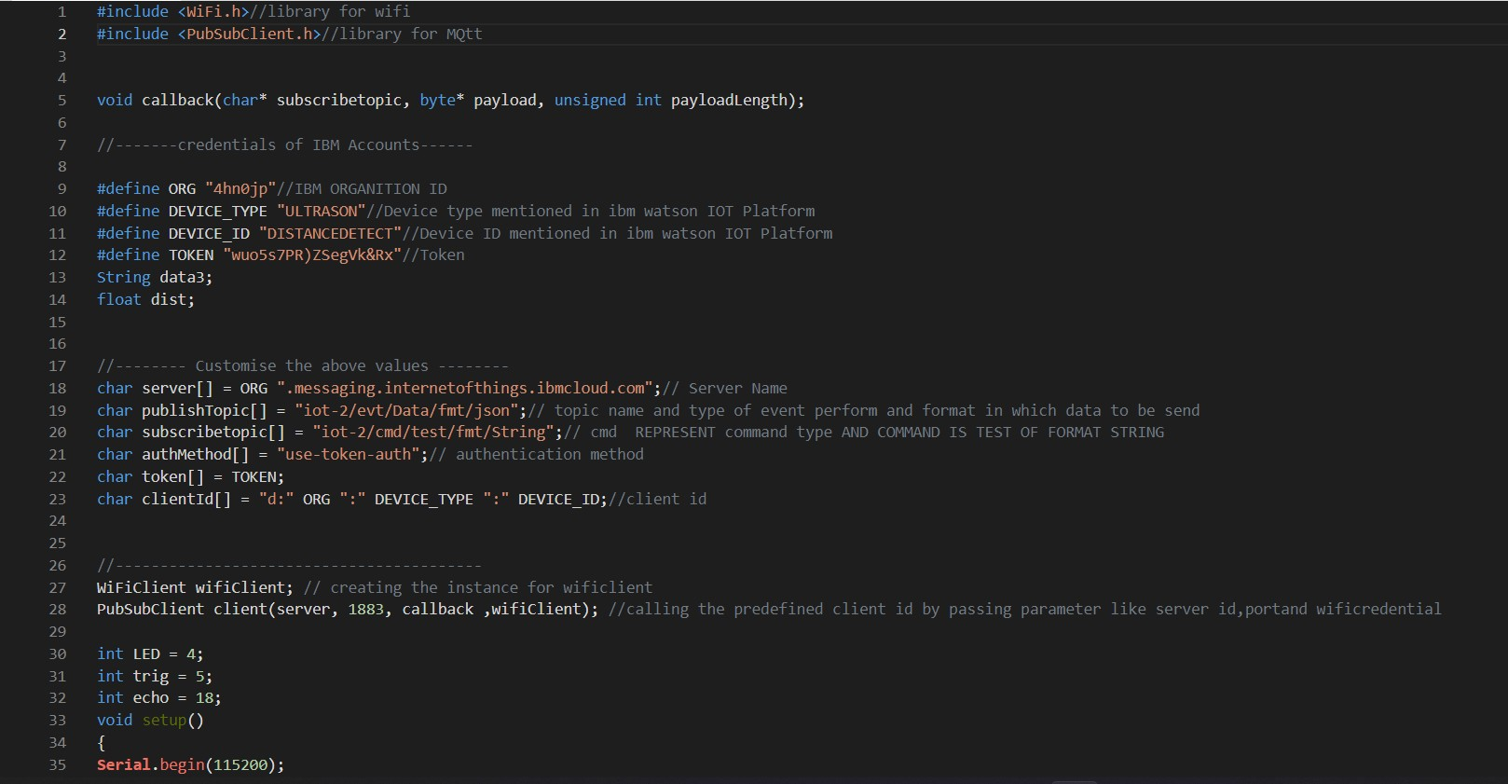CODE :

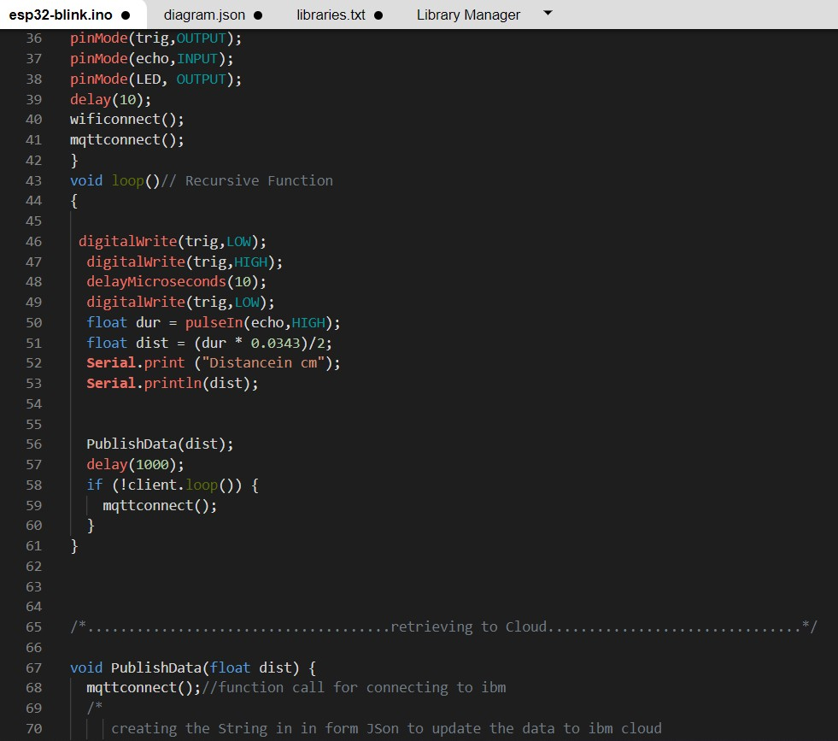

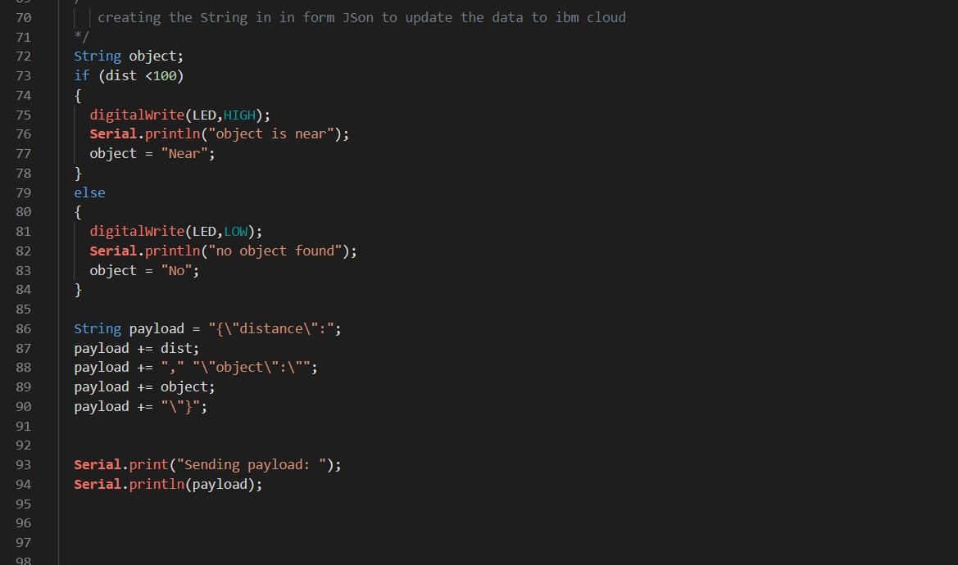

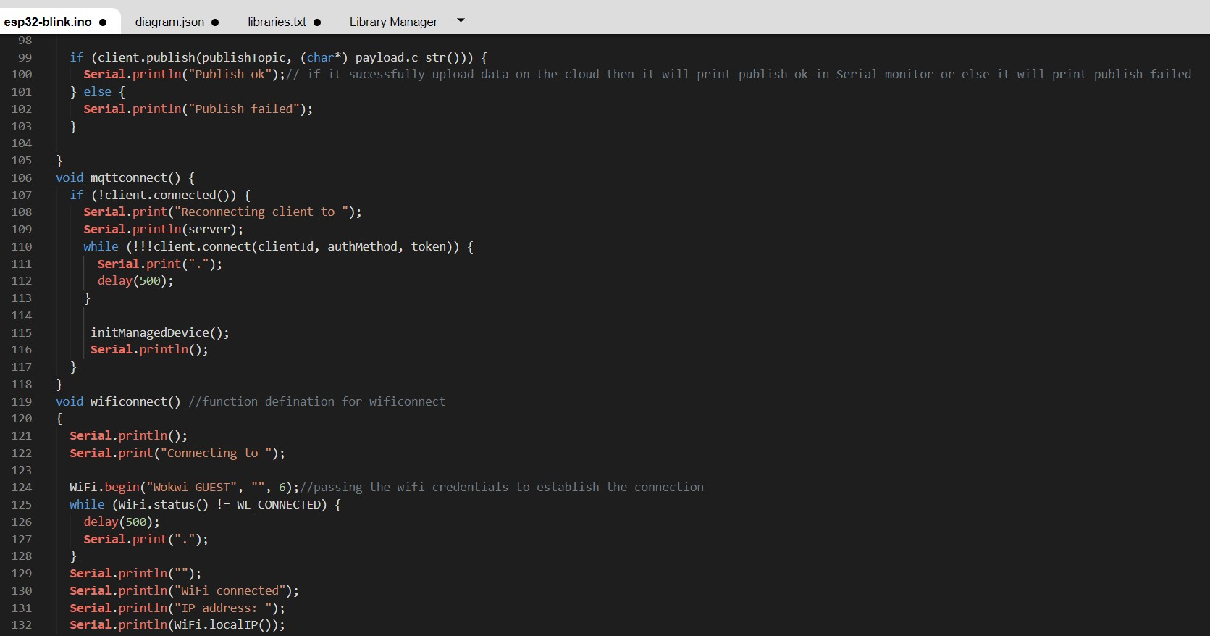

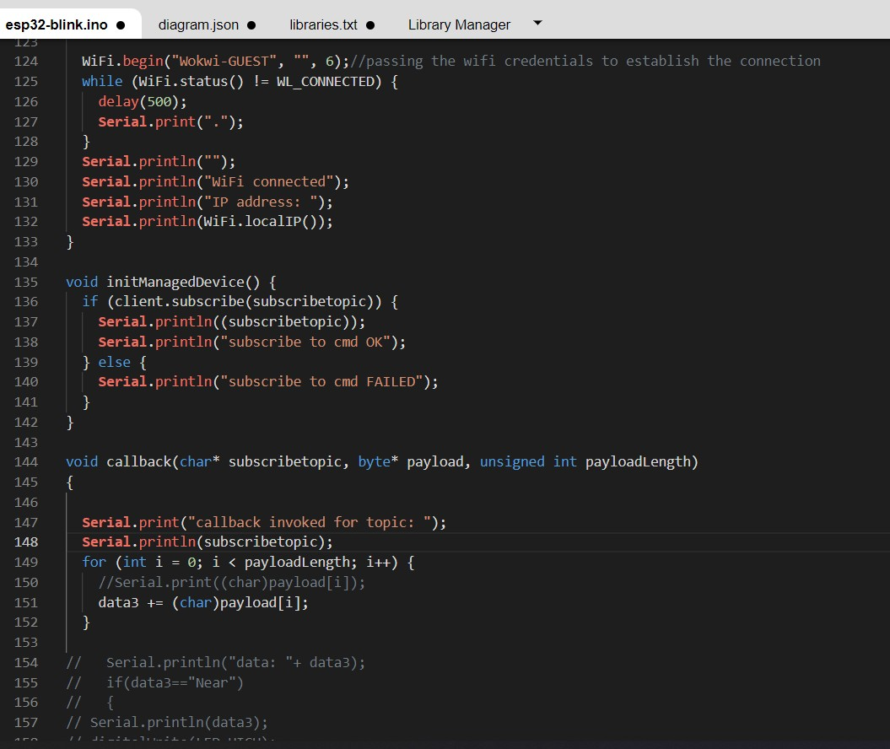

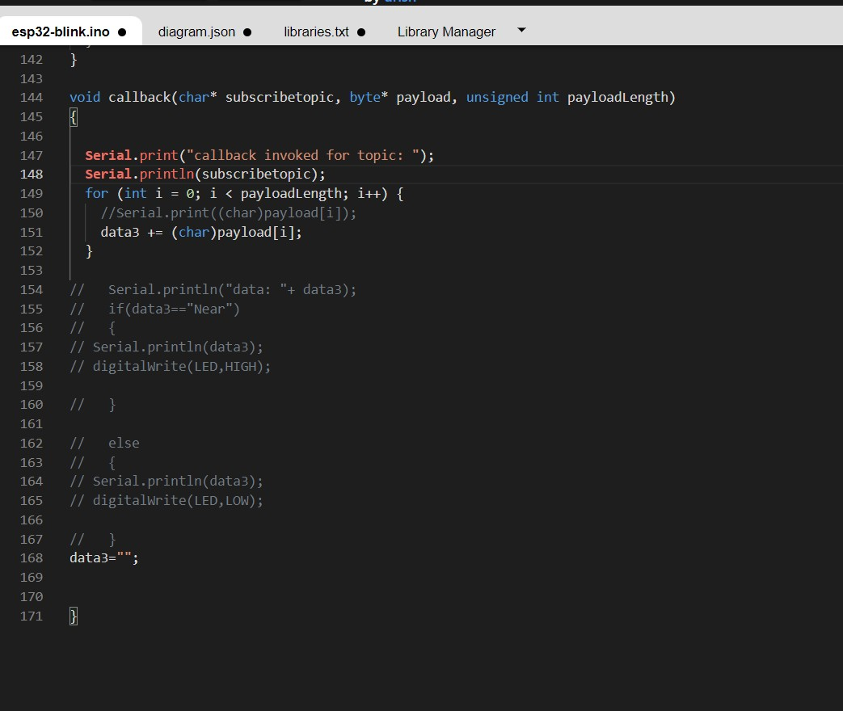

# OUTPUT:

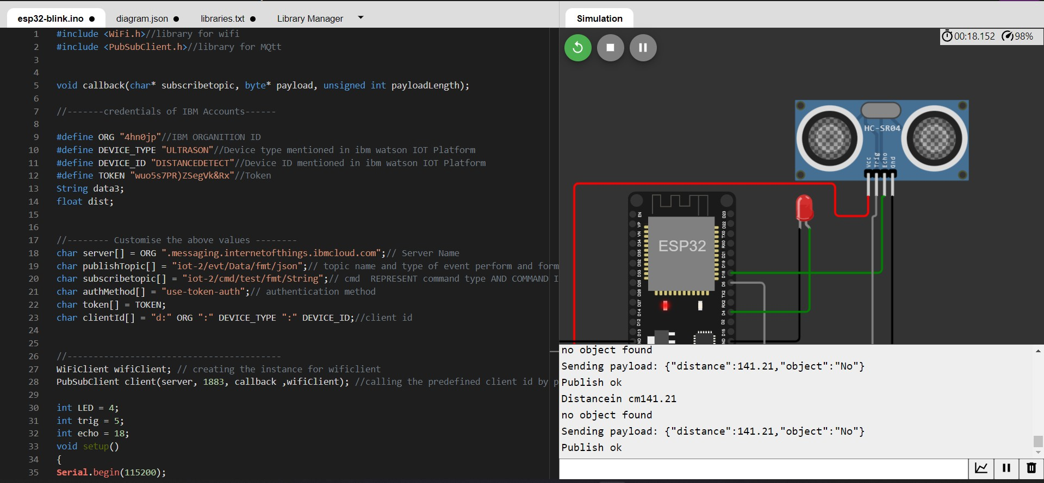

Data send to the IBM cloud device when the object is far

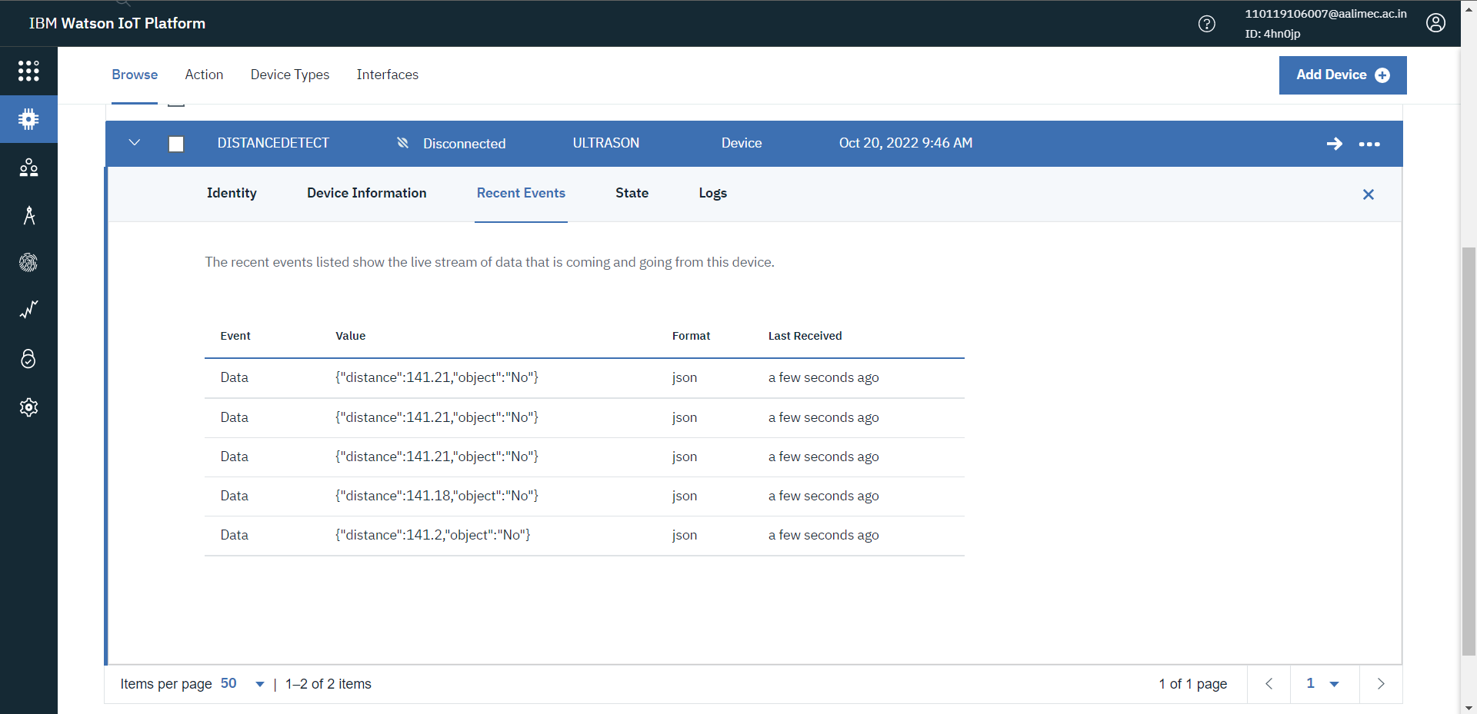

# when object is near to the ultrasonic sensor

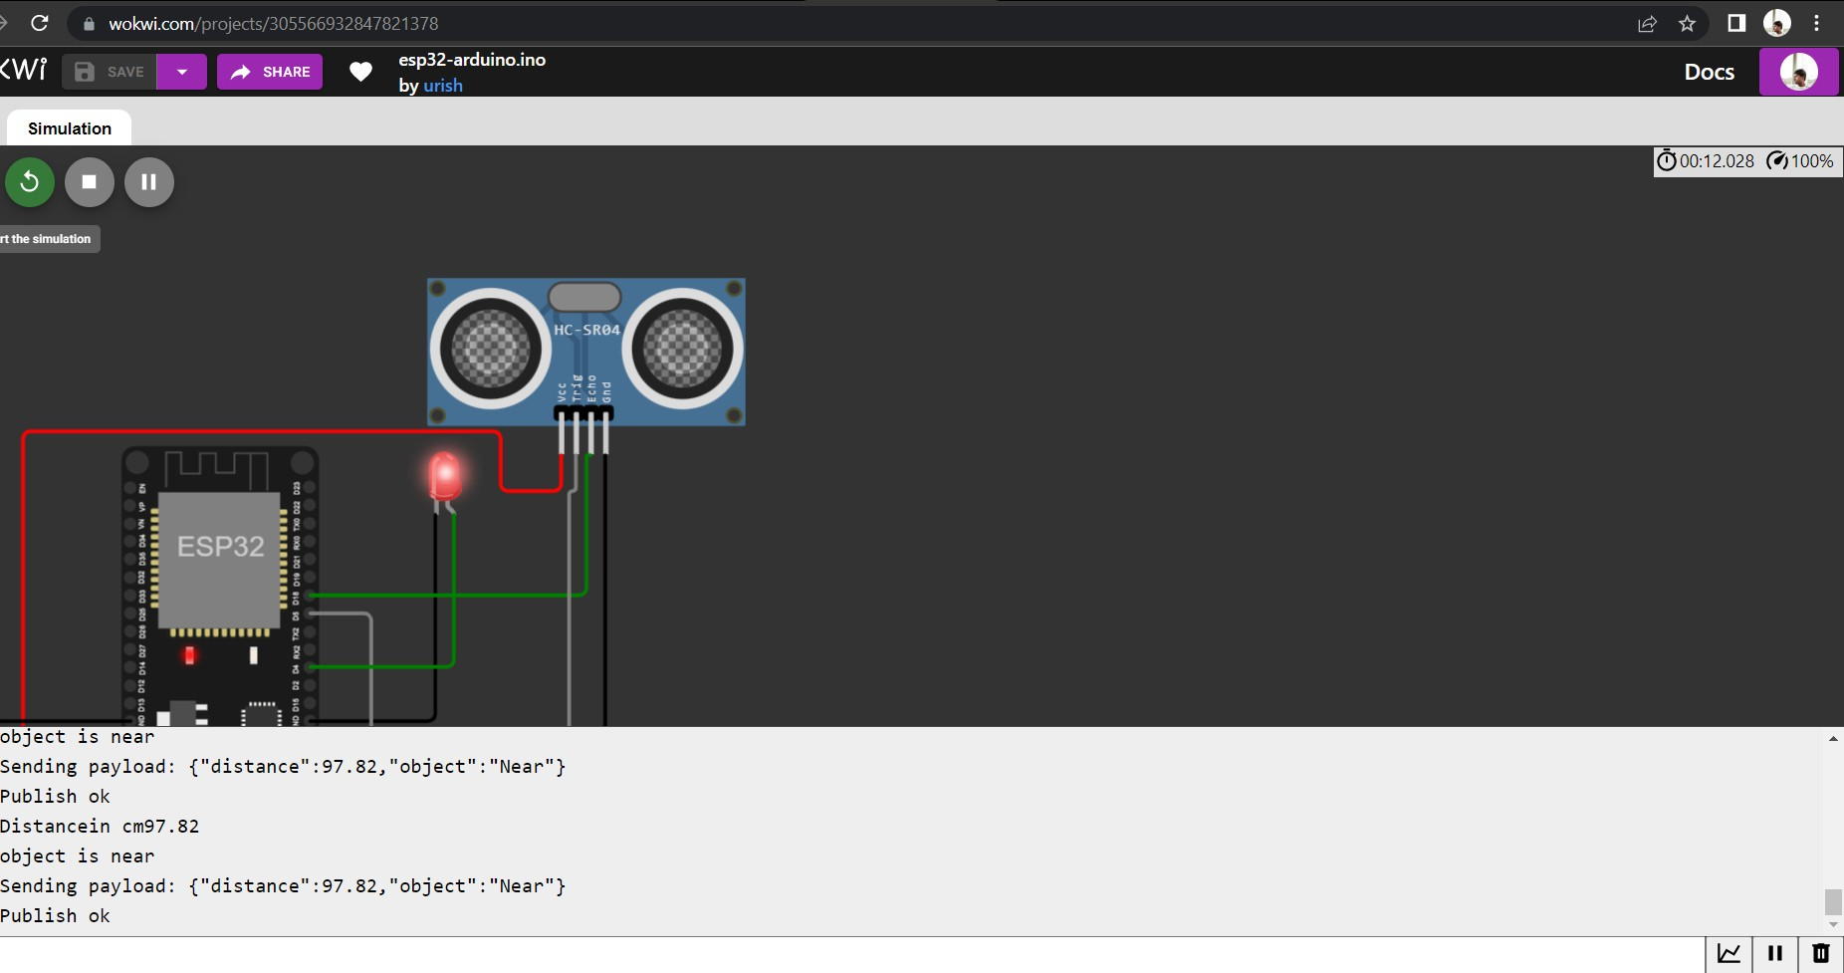

Data sent to the IBM Cloud Device when the object is near

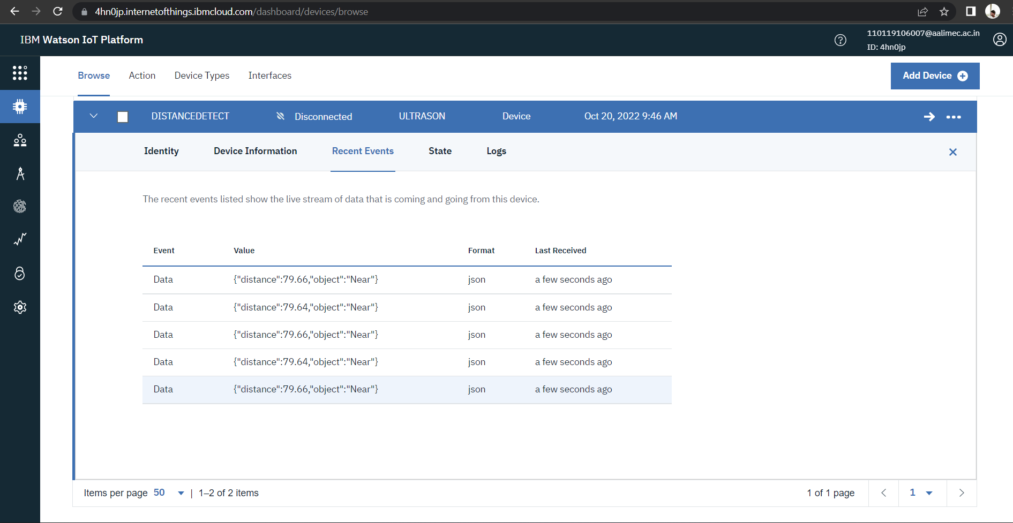

# https://wokwi.com/projects/305566932847821378